

GAS MEASUREMENT SURVEY

In the process industry, there are hundreds of companies interested in SAFE and ACCURATE MEASUREMENT of the MASS-FLOW of GASES, STEAM and LIQUIDS. We identified-and explore (4)-technologies where there are clear ALL-IN-ONE MASS-FLOW METERING SOLUTIONS.
We help reduce process gas costs & enhance process monitoring by using ALL-IN-ONE Mass Flowmeter Solutions that replaces old, outdated, mechanical meters.
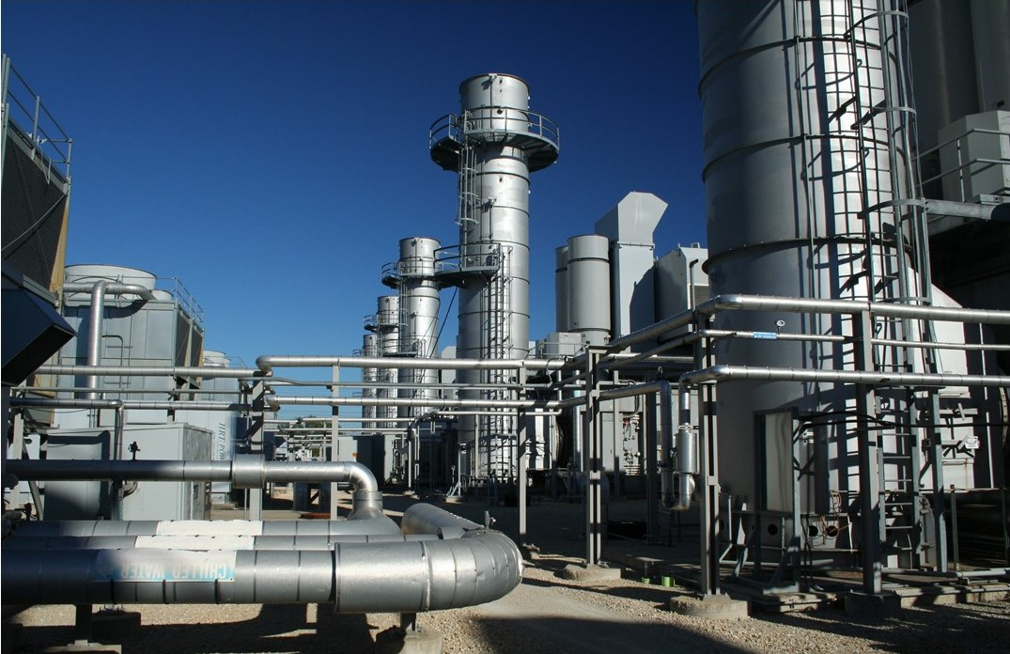
WHY IT'S HARD TO SOLVE THE PROBLEM
In process gas measurement, several factors contribute to safety and inaccuracy issues:
- Changes in Gas Composition, Pressure and Temperature
- Undetected leaks in the Process
- Wide range of flow rate
- Lack of straight run or bypass line
- Moving parts require maintenance
- Meters require calibration

Name Company Date

Title Phone Email

- When did you first learn that 1-PSIG change in gas pressure affects flow accuracy by 1%, 10° F change in temperature affects flow accuracy by 1.8% & gas composition can affect flow accuracy?

- How do you determine what leaks you have in the process?

- What is the range of operation (turndown) for your process conditions?

- Do you know how laminar flow (the bullet shape) enhances flow accuracy?

- When do you pull preventative maintenance/verify/calibrate capital equipment?

- How many air, gas & steam applications do you presently measure?

- What flow technology are you presently using to measure gas flows? Check any/all Orifice Plate

PD Meter Diaphragm VA Meter Turbine Ultrasonic Thermal Coriolis Vortex

8) What are your biggest challenges that you face with gas measurement? Check any/all concerns

Accuracy Repeatability Reliability Calibration Mechanical Design Installation

Service Cost All challenges Other

9) What capital equipment applications have you tried to reduce costs upon in the past? Pick any/all

Process Heating Applications Air Applications Energy/Billing Pure/Mixed Gas

Other Applications

**Bonus Question** What is the keyword from the 5-minute K&I video?

Toll Free (844) GAS-FLOW scott@k-iinstruments.com

